Integrated Installation

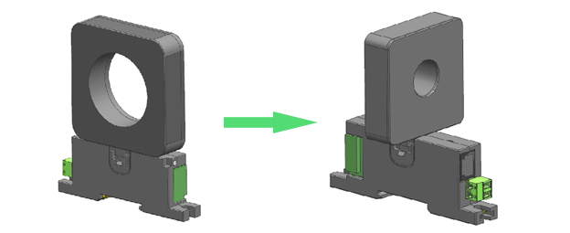

Integrated installation, a rotating structure can be used in the perforated part.

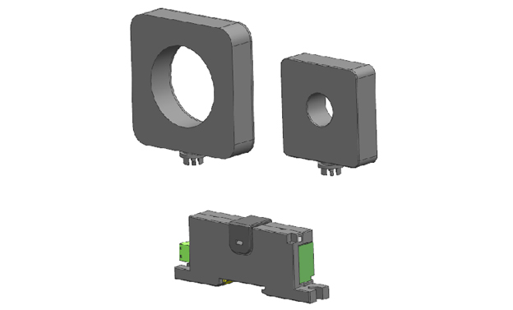

There are Φ20, Φ50 of hole sizes for your selection.

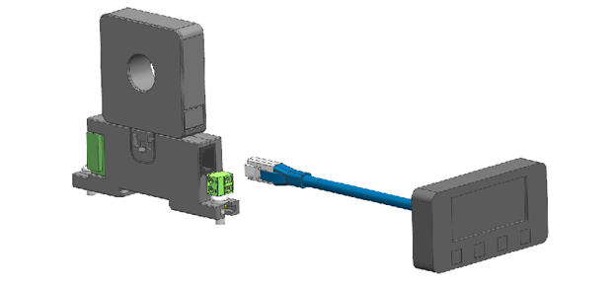

The main body could be connected to the display screen in order to display current and set parameters when integrated installation ( use existing display screen as far as possible).

Split-type Installation

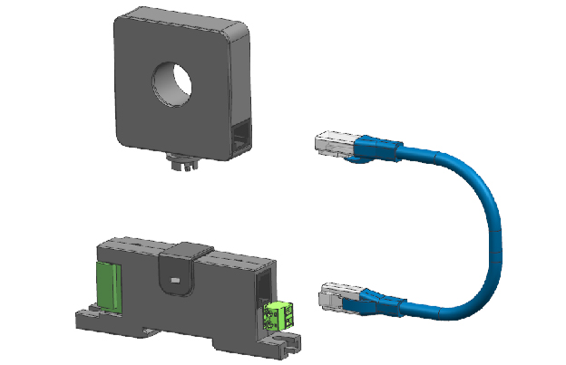

The current transformer is connected to the main body through network cable when using split-type connection.

Other types of Installation

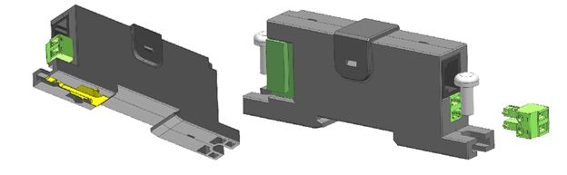

TS3 din-rail mounting, or fix it on the cabinet with screws.